3 Best Upright Exercise Bikes for Home in 2026
Meta description: Find the three best upright exercise bikes for home in 2026 with specs on flywheel weight, resistance levels, displays, pedal design, and warranty coverage.
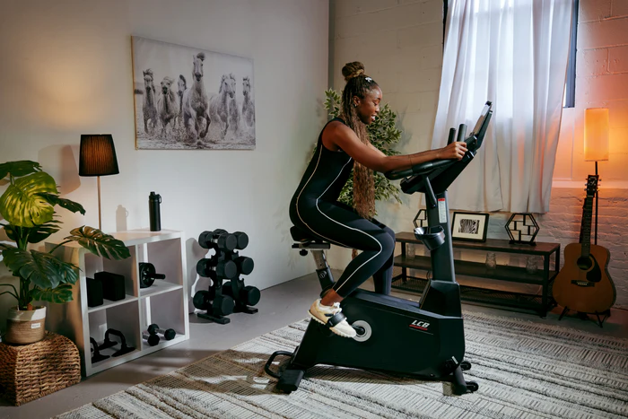
Alt text: Woman pedaling on the SOLE LCB upright exercise bike in a decorated living room with a dumbbell rack, horse canvas print, guitar, and plants.

Key Takeaways
- Upright bikes offer an ideal balance of effective cardio and comfort, engaging your core more than recumbent bikes without the aggressive positioning of spin bikes.
- Flywheel weight is the biggest factor in ride quality; budget bikes use 10–15 lbs while quality home bikes use 20–30 lbs for smoother, more consistent pedal strokes.
- Lifetime frame warranties signal commercial-grade durability, while subscription-free workout content eliminates ongoing costs that erode the value of your initial investment.
- The SOLE LCB delivers commercial-grade performance at $1,499.99 with a 30 lb flywheel, 40 resistance levels, 10.1-inch touchscreen with built-in streaming, PT-designed cushioned pedals, and the FREE SOLE+ App without subscription fees.
- The SOLE B94 hits the value sweet spot at $899.99 with a 20 lb flywheel, adjustable gel seat, and the same lifetime frame warranty as SOLE's premium models.

Upright Bikes vs. Other Cardio Options
The three best upright exercise bikes for home in 2026 are the SOLE LCB, the SOLE B94, and the Schwinn 170, each suited to a different budget and training goal. Upright exercise bikes place you in a natural cycling position with pedals directly beneath your hips. This posture engages your core throughout the workout because you're constantly stabilizing your torso.
Compared to recumbent bikes where you sit back with pedals in front, upright bikes provide a more intense workout in less time. You burn more calories at the same resistance level because more muscle groups are working.
Compared to spin bikes designed for standing sprints and aggressive road cycling positions, upright bikes offer a more comfortable, sustainable workout for daily use. The upright position is easier on your lower back and doesn't require cycling-specific flexibility.
For most home gym users, an upright bike hits the sweet spot: effective cardio without the learning curve or discomfort of specialized equipment.

Premium Home Gym Equipment with Award-Winning Quality!

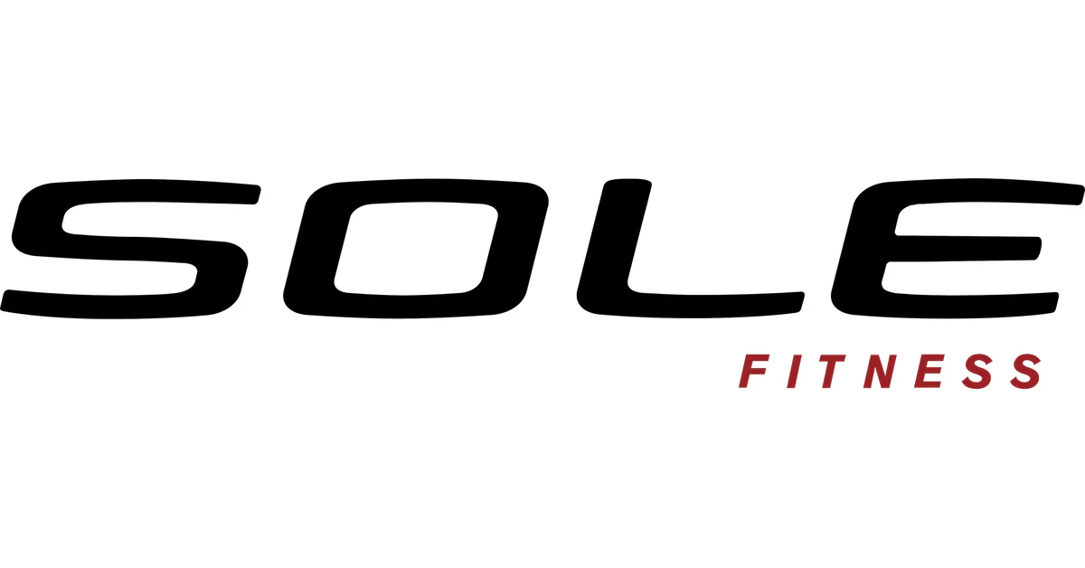

Complete Your Home Gym:

- Treadmills (commercial-grade motors)
- Ellipticals (whisper-quiet operation)
- Exercise Bikes (all riding styles)
- Rowing Machine ('on water' sensation)
- Strength Equipment (dumbbells, barbells, benches)
- Revolutionary SRVO motorized trainer

Why Choose SOLE:
✓ Commercial-grade quality for home use
✓ Weight capacity up to 400 lbs on selected equipment
✓ Industry-leading warranty coverage
✓ FREE curbside shipping nationwide
✓ Thousands of FREE workout classes via SOLE+ app
✓Exceptional customer service rated "Best"

30-Day Money-Back Guarantee: Love it or return it, no questions asked.

Shop SOLE Fitness Now →

The 3 Best Upright Exercise Bikes for Home

1. SOLE LCB: Best Overall Upright Bike
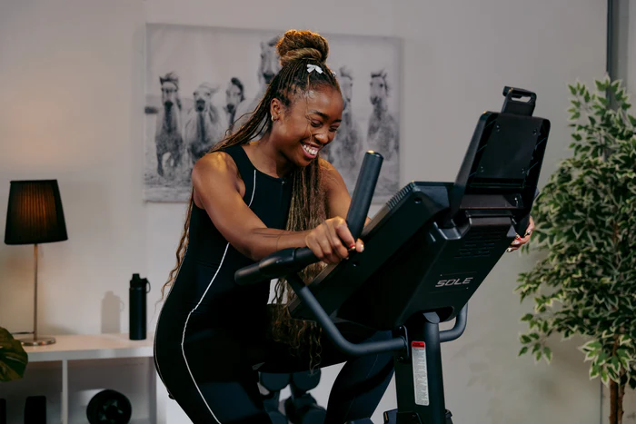Caption: The SOLE LCB features a 30-lb flywheel with 40 resistance levels for commercial-grade performance at home.
Alt text: Woman smiling while riding a SOLE LCB exercise bike in a home setting with a floor lamp, horse canvas print, and potted plant in the background.
The LCB is SOLE's light commercial upright bike, designed for apartment gyms, physical therapy clinics, and demanding home users.
The 30-pound flywheel creates ride quality that matches commercial gym equipment. Transitions between pedal strokes feel seamless. There's no choppy resistance at higher speeds, no momentum loss at the top of each rotation.
40 resistance levels provide twice the adjustment range of standard home bikes. This granular control matters for interval training and progressive overload. You can make micro-adjustments rather than jumping between settings that feel too easy and too hard.
The 10.1" touchscreen runs built-in streaming apps including Netflix, YouTube, and Amazon Prime. Screen mirroring displays content from your phone. The FREE SOLE+ App provides hundreds of coached workouts without subscription fees.
The cushioned pedals feature SOLE's 2-degree inward angle, developed with a physical therapist to reduce knee and ankle stress. This design becomes noticeable during longer sessions when fatigue sets in and form tends to break down.
Wireless charging keeps your phone powered. Bluetooth speakers let you listen without headphones. The 350-lb weight capacity and 112-lb machine weight keep the bike firmly planted during intense efforts.

2. SOLE B94: Best Value Upright Bike
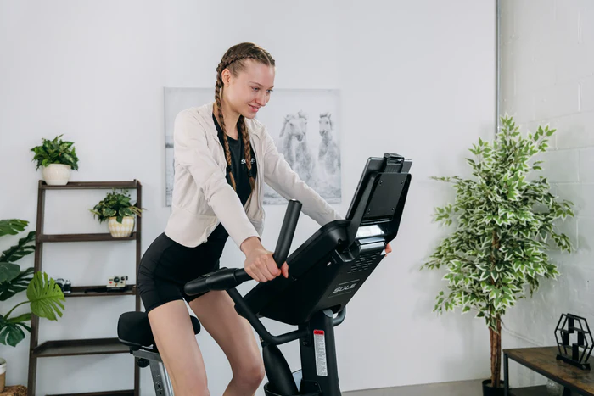Caption: The SOLE B94 delivers smooth, quiet workouts with a 20-lb flywheel and adjustable gel seat.
Alt text: Woman riding a SOLE B94 upright exercise bike in a bright room with a horse canvas print, a ladder shelf with plants, and a potted tree in the background.
The B94 demonstrates that you don't need to spend $1,500 to get a quality upright bike. It delivers SOLE's core strengths at a price that competes with budget brands offering far less.
The 20-pound flywheel provides smooth, quiet operation. It's heavier than most bikes in this price range, which typically use 10-15 lb flywheels. The difference shows up in ride quality: consistent momentum without the stuttering feel of lighter systems.
20 resistance levels with eddy current braking offer plenty of range for beginners and experienced cyclists alike. The magnetic system operates quietly enough for apartment use and early-morning workouts.
The 9" backlit LCD displays workout metrics clearly without the complexity of a touchscreen. An integrated tablet holder positions your device at eye level for streaming content from your own apps.
The adjustable gel seat provides genuine comfort for longer sessions. Both vertical and horizontal adjustments let you set the exact position for your body. The ergonomic pedals with straps keep your feet secure.
The frame is lighter than the LCB (101 lbs vs 112 lbs) but still provides stable performance up to the 300-lb weight capacity. Transport wheels make repositioning easy.
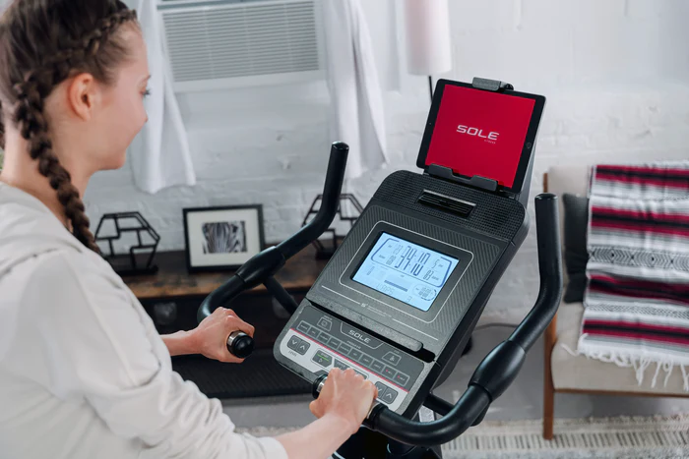Caption: Heavy flywheels and magnetic resistance systems create smooth, quiet workouts that feel like commercial gym equipment.
Alt text: Woman adjusting controls on SOLE B94 exercise bike console with a backlit LCD display and a tablet mounted above showing the SOLE app, in a bright home setting.

3. Schwinn 170
SOLE does not manufacture or sell the Schwinn 170. This is an independent review of a product for comparison purposes.
The Schwinn 170 is an entry-level upright bike aimed at budget-conscious buyers. It's a capable bike that delivers real workouts at a lower price point.
The perimeter-weighted flywheel uses a high-speed, high-inertia design that distributes weight along the flywheel's edge to maximize momentum. The result is smoother than you'd expect from a budget bike, though not as refined as heavier systems.
25 resistance levels provide solid range for varied workouts. The eddy current magnetic system operates quietly and requires minimal maintenance.
The DualTrack two LCD screen system displays workout metrics across two blue backlit panels. It's not a touchscreen, but the displays show everything you need: time, distance, calories, heart rate, resistance level, and program status.
29 built-in programs give you workout variety without requiring a subscription. Options include 12 profile programs, 9 heart rate programs, 4 custom programs, 2 fitness tests, 1 recovery test, and quick start mode.
Bluetooth connectivity syncs with the Explore the World app and fitness trackers like MyFitnessPal. Built-in speakers play audio from your phone through the MP3 input. A three-speed adjustable fan helps keep you cool.
The 300-lb weight capacity handles most users. The padded, contoured seat adjusts vertically and horizontally, and can be exchanged with any clamp and rail bicycle seat. The frame warranty of 10 years provides long-term coverage.

Upright Bike Comparison
Feature | SOLE LCB | SOLE B94 | Schwinn 170
Price | $1,499.99 | $899.99 | $399
Best for | Premium performance | Best value | Budget option
Flywheel | 30 lbs | 20 lbs | Perimeter-weighted
Resistance levels | 40 | 20 | 25
Resistance type | Magnetic | Eddy current | Eddy current
Display | 10.1" touchscreen | 9" LCD | Dual LCD
Built-in programs | 22 | 9 | 29
Streaming apps | Yes | No | No
Tablet holder | Yes | Yes | Yes
Bluetooth | Yes | Yes | Yes
WiFi | Yes | No | No
Wireless charging | Yes | No | No
FREE SOLE+ App | Yes | Yes | N/A
Subscription required | No | No | No
Cushioned pedals | Yes (2° slope) | Yes | No
Weight capacity | 350 lbs | 300 lbs | 300 lbs
Machine weight | 112 lbs | 101 lbs | N/A
Frame warranty | Lifetime | Lifetime | 10 years
Commercial warranty | Yes | No | No

*Disclaimer: Products and prices mentioned in this article are accurate as of the date of publication and are subject to change. Please visit the official SOLE website for the most current information.

Why SOLE Upright Bikes Stand Out
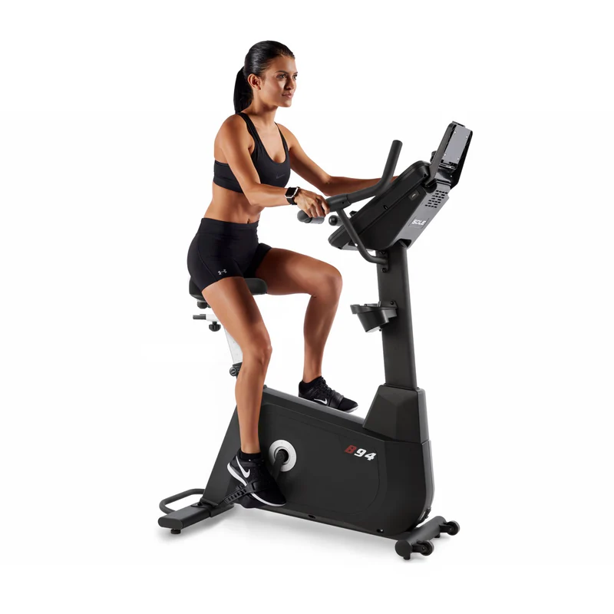Caption: SOLE upright bikes combine commercial-grade construction with subscription-free features.
Alt text: Woman pedaling on the SOLE B94 upright exercise bike shown in profile view against a white background.
At SOLE, we build upright bikes that deliver commercial-grade performance without commercial pricing or ongoing subscription fees.
Our LCB features a 30-lb flywheel and 40 resistance levels, matching equipment found in professional gyms at a fraction of the cost. At $1,499.99, it includes built-in streaming apps, the FREE SOLE+ App with hundreds of coached workouts, and a light commercial warranty.
Our B94 hits the value sweet spot at $899.99. The 20-lb flywheel and adjustable gel seat provide quality workouts without the touchscreen premium. You get the same lifetime frame warranty and FREE SOLE+ App access.
Both bikes feature our signature cushioned pedals with a 2-degree inward slope, developed with a physical therapist to reduce joint stress. Both include Bluetooth connectivity and tablet holders, so setup is straightforward and training starts immediately.
Shop SOLE Upright Bikes Today!

Frequently Asked Questions (FAQs)

How long should I use an upright bike each day?
For general fitness, 20–30 minutes of moderate cycling provides solid cardiovascular benefits. Beginners should start with 10-15 minute sessions and build duration gradually. The American Heart Association recommends 150 minutes of moderate cardio per week, which works out to about 30 minutes five days per week.

Are upright bikes good for weight loss?
Yes. A 155-pound person burns approximately 252 calories during 30 minutes of moderate stationary cycling, according to Harvard Health. Higher resistance and interval training increase calorie burn. Combined with a balanced diet, regular upright bike workouts support sustainable weight loss.

What's the difference between an upright bike and a spin bike?
Upright bikes position you in a comfortable, relatively upright posture suitable for longer, moderate-intensity sessions. Spin bikes position you more aggressively (leaning forward) for high-intensity training that includes standing sprints. Spin bikes typically use heavier flywheels and are designed for cycling enthusiasts who want to simulate outdoor riding.

Is a 20-lb flywheel heavy enough?
For most home users, yes. A 20-lb flywheel like the one in the SOLE B94 provides smooth, consistent momentum. You'll notice the difference compared to budget bikes with lighter flywheels. However, if you're an experienced cyclist or plan intense daily training, the 30-lb flywheel in the LCB delivers noticeably better performance.

What warranty does SOLE offer on upright bikes?
SOLE provides a lifetime frame warranty on both the LCB and B94. The LCB includes 3 years parts coverage and 1 year labor. The B94 includes 2 years parts and 1 year labor. The LCB also offers a light commercial warranty (2 years parts, 1 year labor, lifetime frame) for business use.

